Git Setup Process –
- Download git installer from git source – https://git-scm.com/install/windows OR In VS Code – branch icon > open “Diownload Git for Windows”
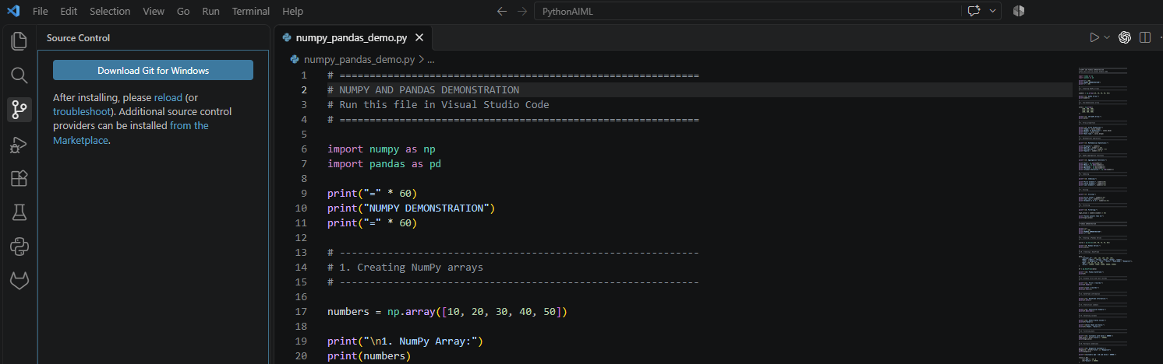
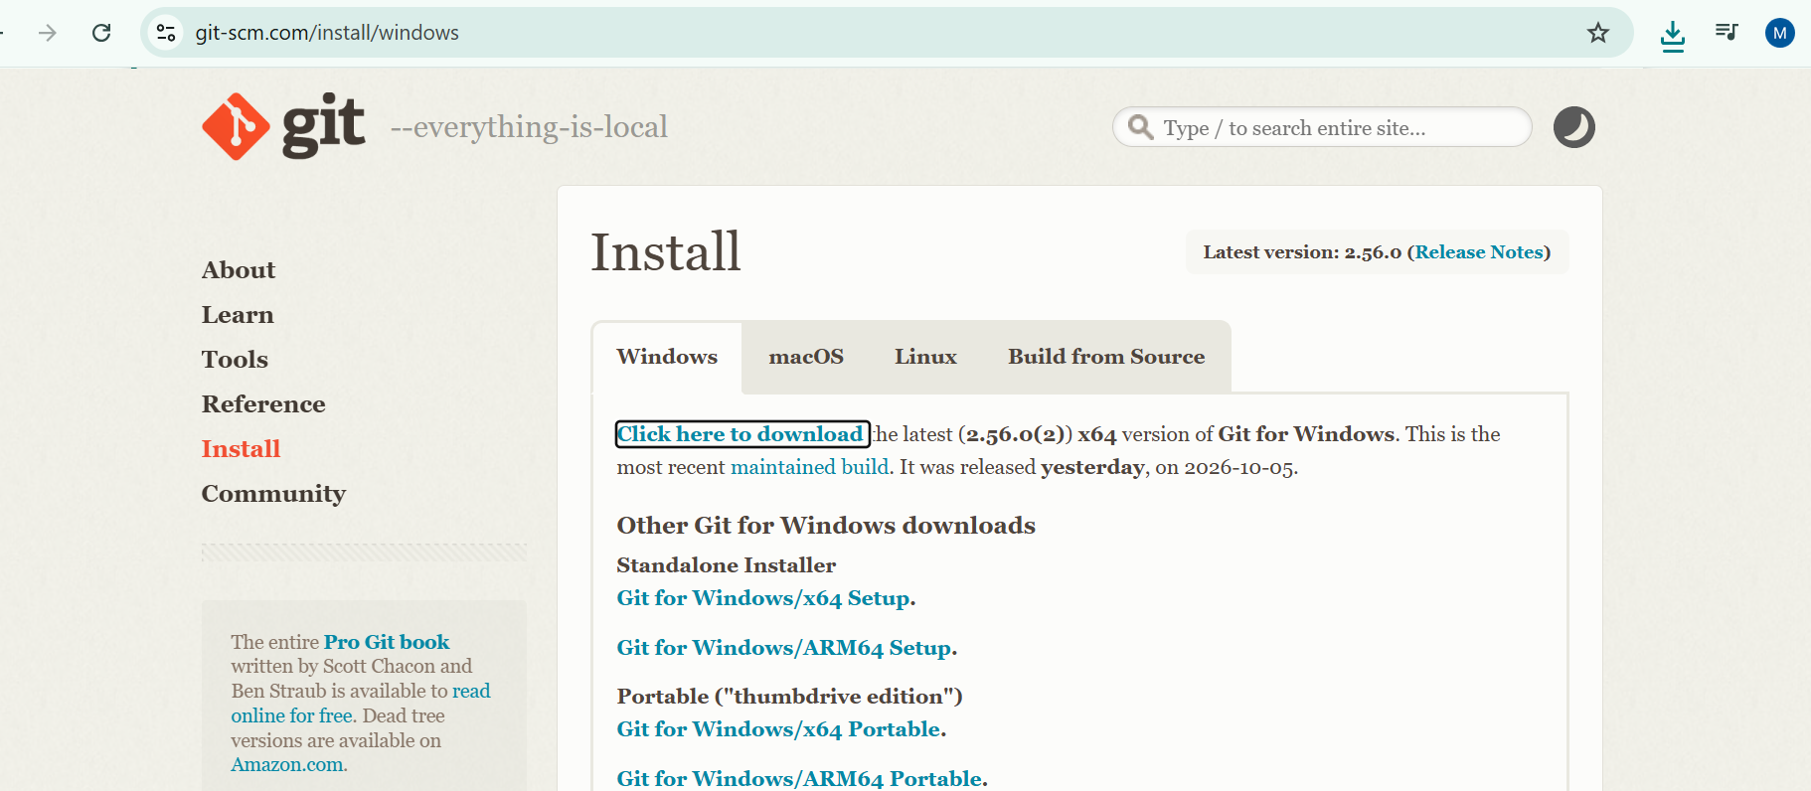
- Execute installed installer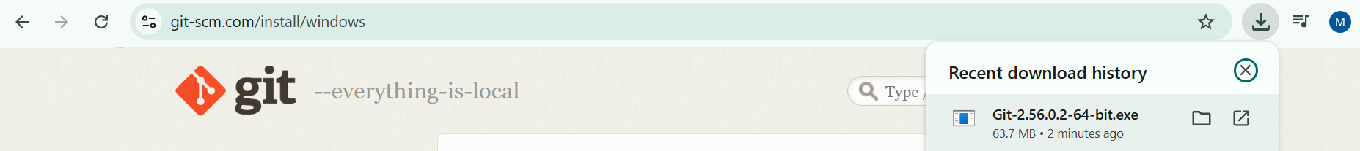
- Select -> Next
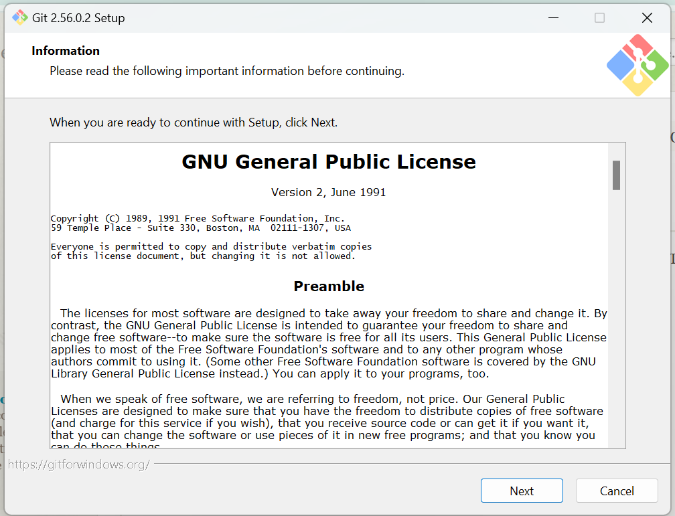

- Check the setup folder location and click Next
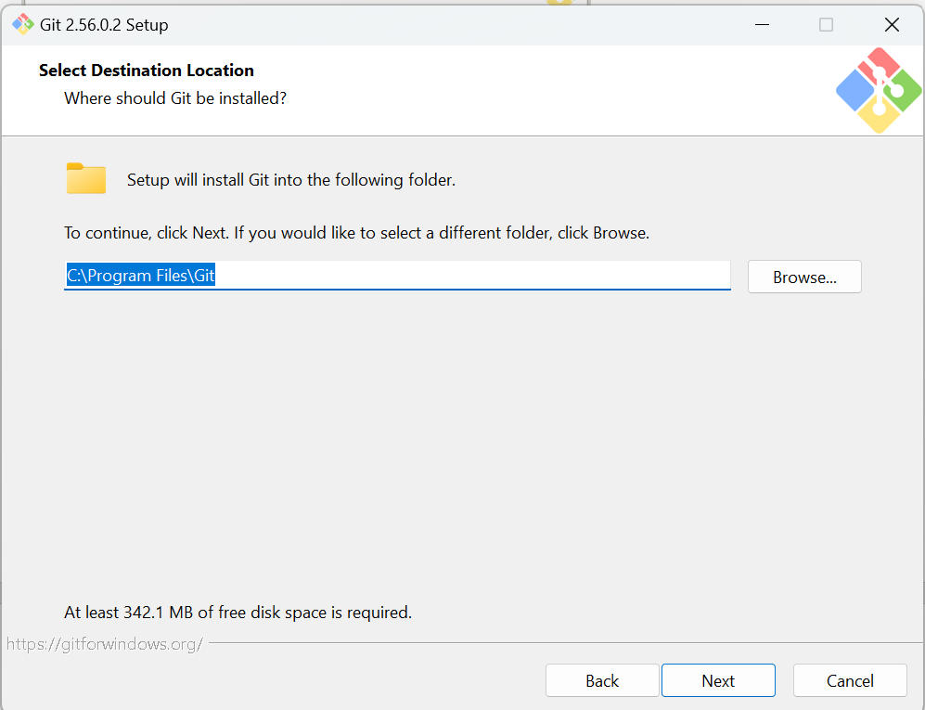
- Click Next-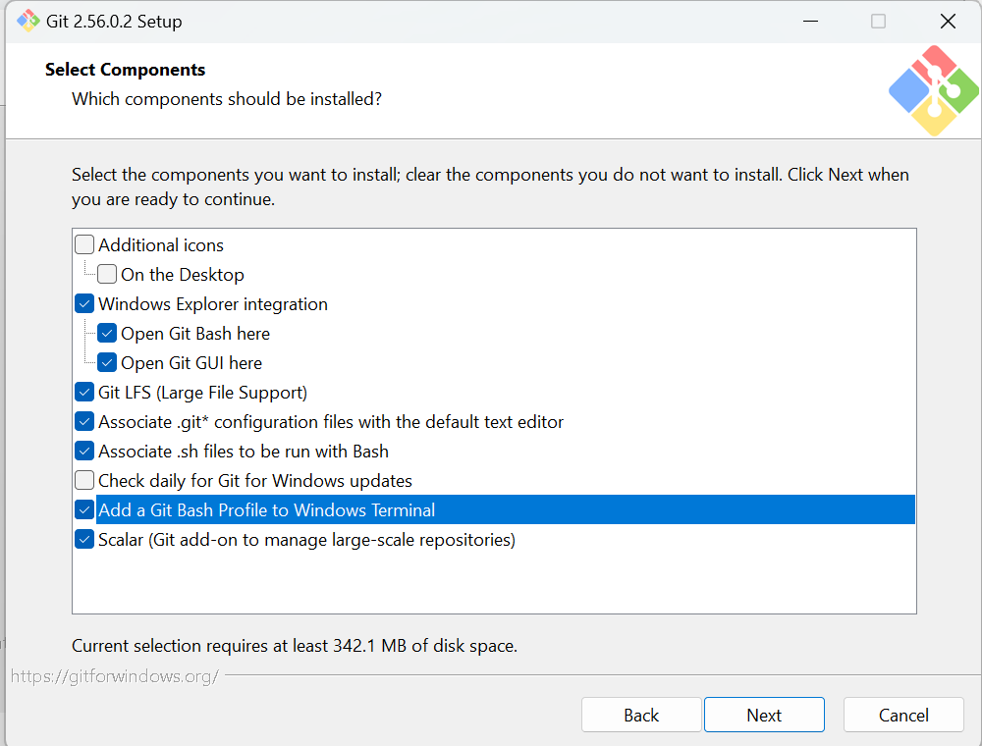

- 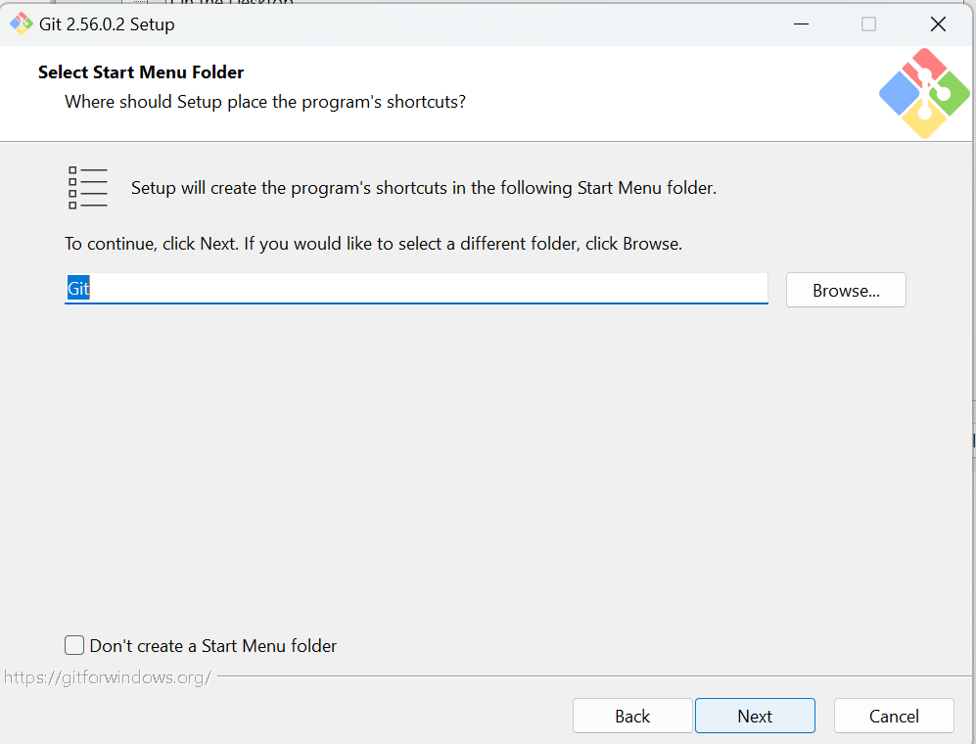

- 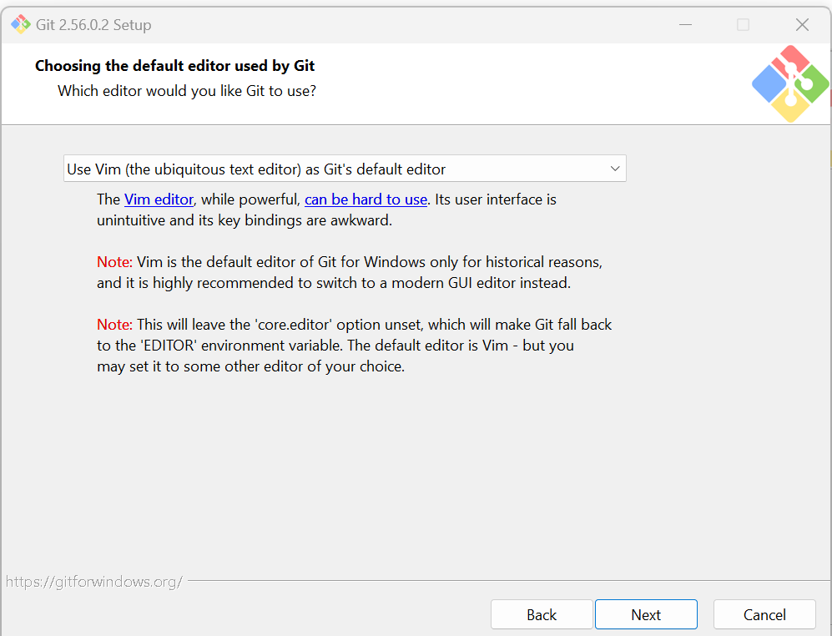

- 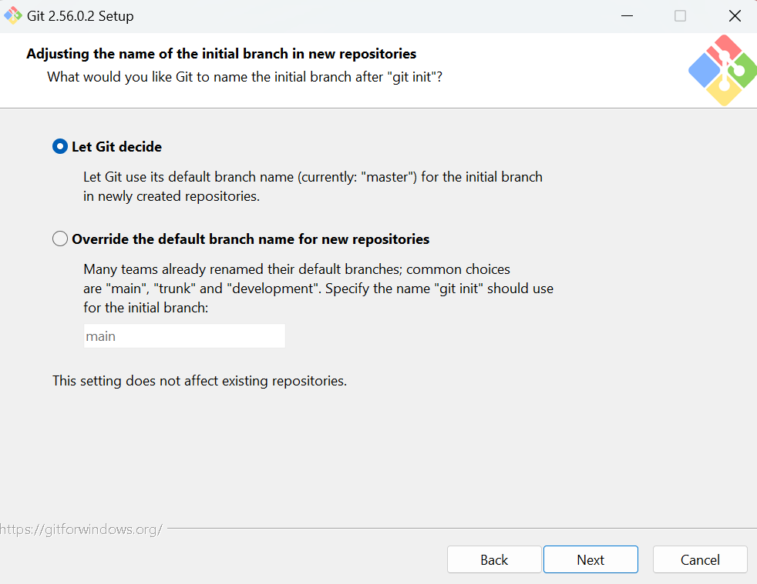

- 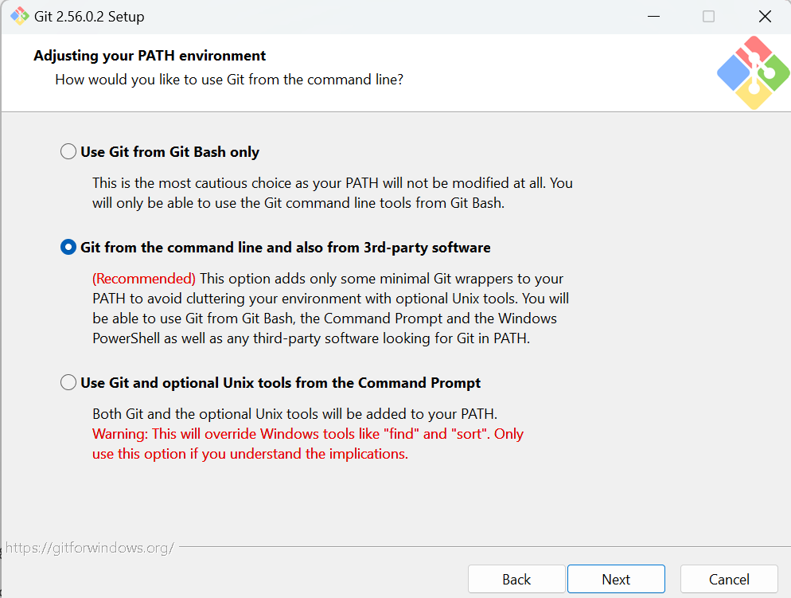

- 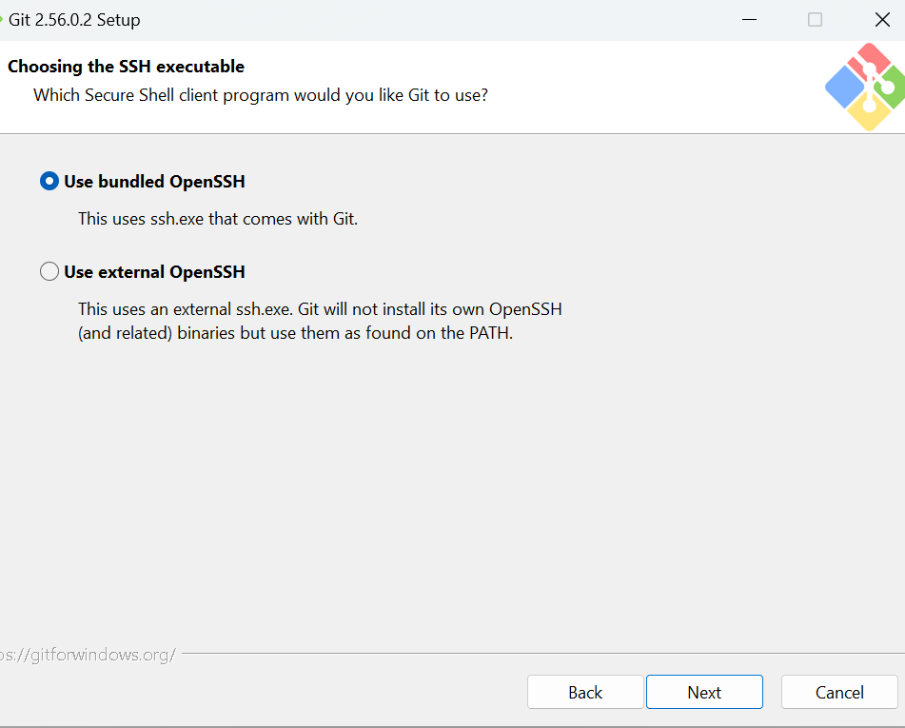

- 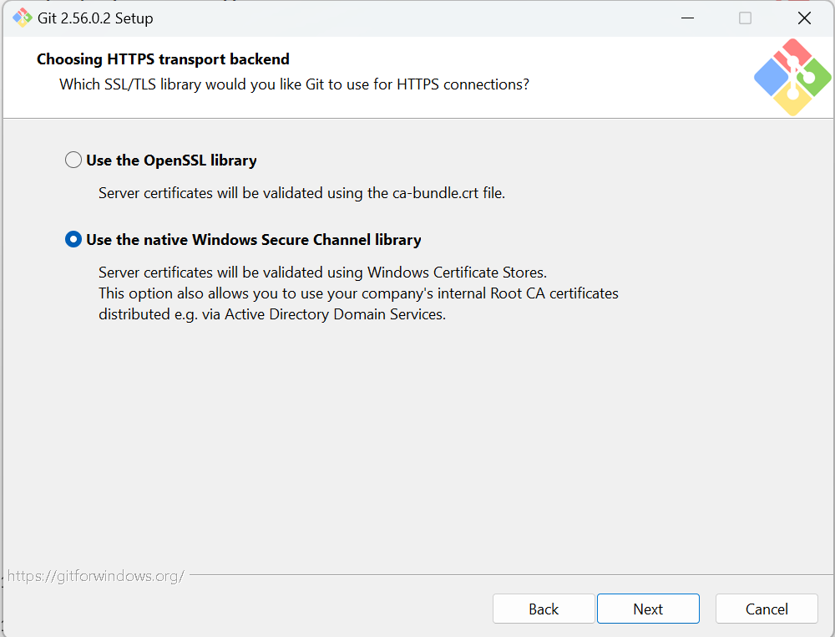

- 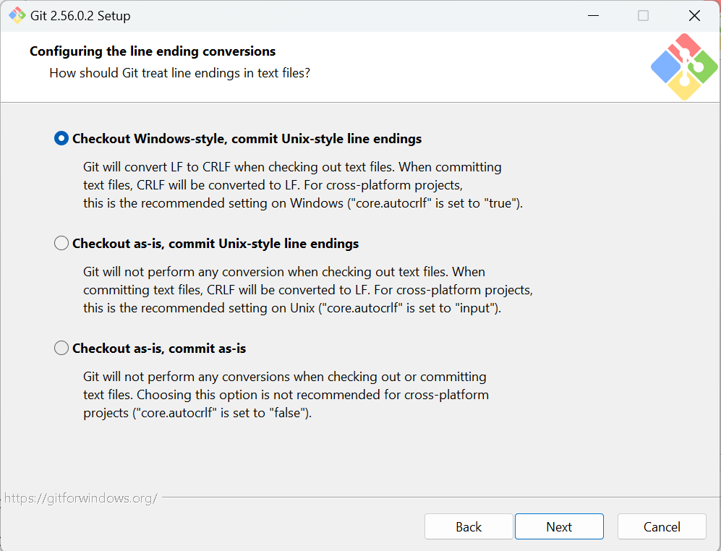

- 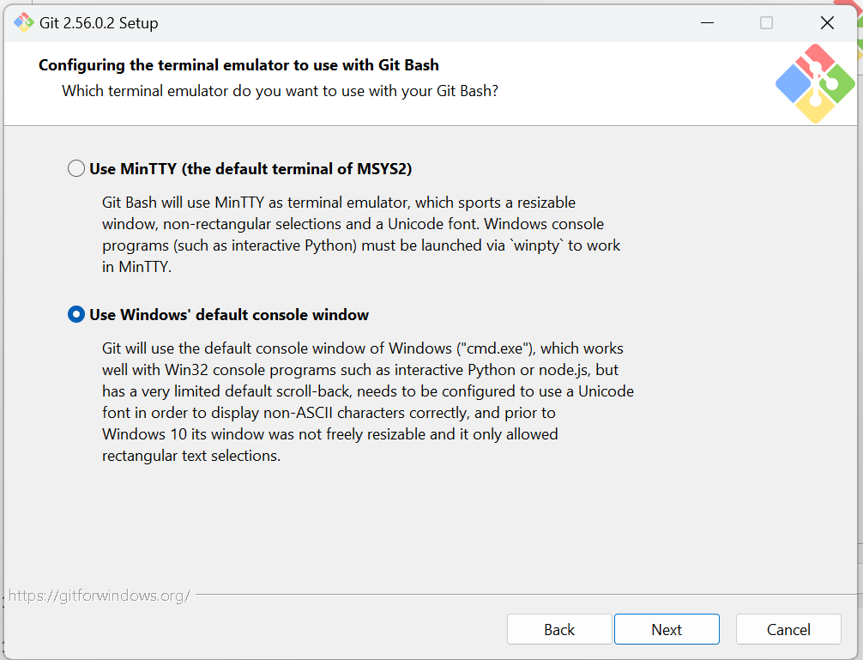

- 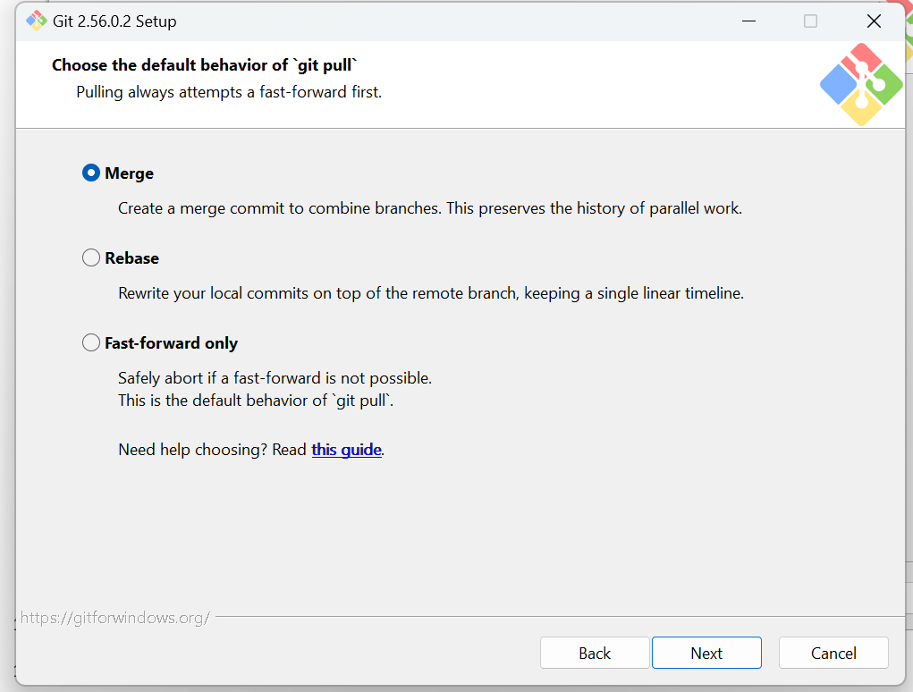

- 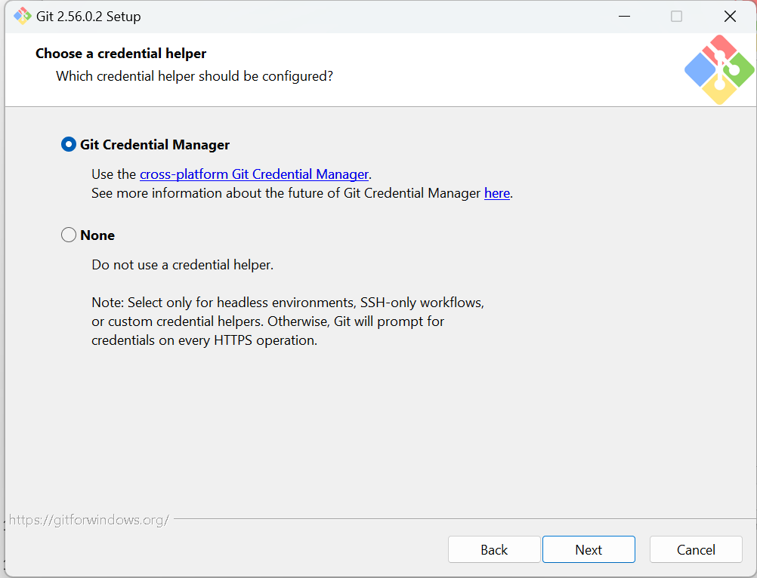

- 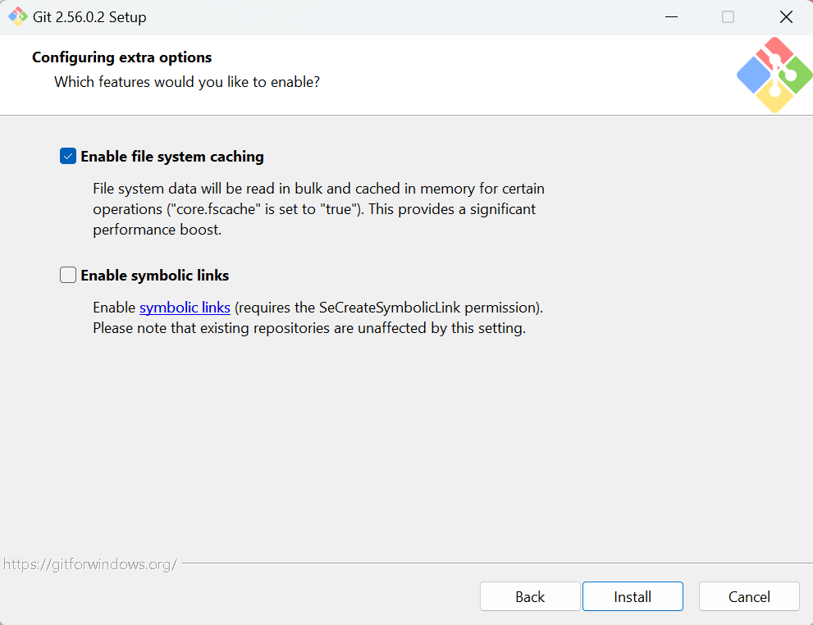

- 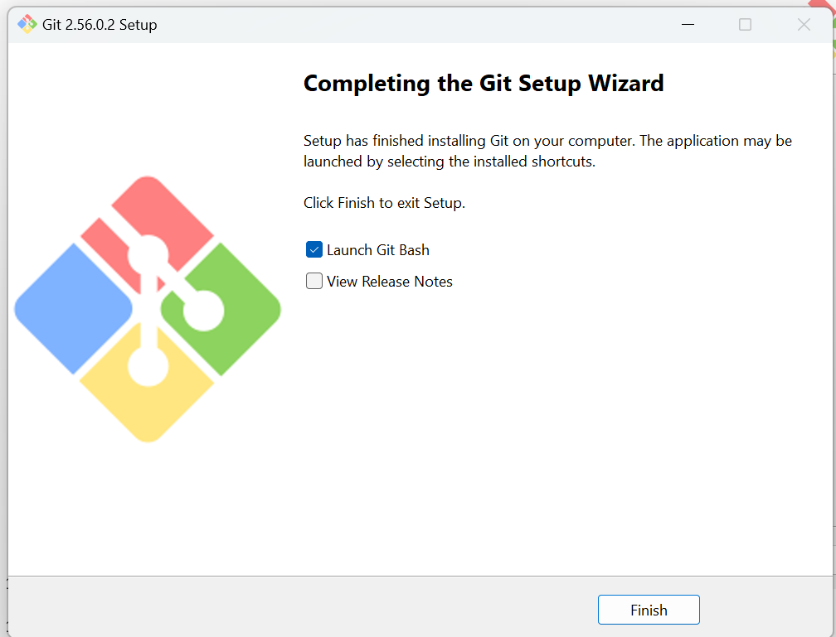

- In cmd > Check git version
git –version
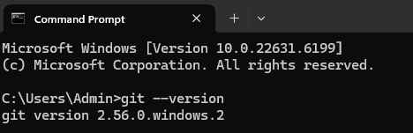

- Restart VS Code after installation.

2. Set your name and email
Open Terminal → New Terminal in VS Code and run these commands, using the name and email you want recorded on your commits:
git config --global user.name "Your Name"
git config --global user.email "you@example.com"
Check the settings:
git config --global --list

3. Open your project in VS Code
- In VS Code, choose File → Open Folder.
- Select your project folder, such as D:\VVIT\PythonAIML.
- Open Source Control from the left sidebar, or press Ctrl+Shift+G.

4. Start Git in the project
If the folder is not already a Git repository, select Initialize Repository in Source Control.
Or run this in the terminal from the project folder:
git init

5. Choose what to track
Create a .gitignore file in the project folder for files Git should skip. For a Python project, a basic starting point is:
__pycache__/
*.py[cod]
.venv/
venv/
.env
Review the Source Control changes list. Stage only the files you want in the first commit. In the terminal, you can stage everything not ignored with:
git add .

6. Make the first commit
Enter a message such as Initial commit in the Source Control message box and select Commit.
Or use the terminal:
git commit -m "Initial commit"

7. Optional: connect to GitHub
Create an empty repository on GitHub. Then, in the VS Code terminal, add its URL and push:
git remote add origin https://github.com/USERNAME/REPOSITORY.git
git branch -M main
git push -u origin main
VS Code may prompt you to sign in to GitHub. Follow the browser prompt to authorize it.

Useful checks
git status
git log --oneline
git status shows what is staged or changed; git log --oneline shows your commits.

